18-甲基系列
Product name | Levonogestrel
Chemical name | D(-)-17α-Ethynyl-17β-hydroxy-18-methylestra-4-en-3-one
Chemical structure | 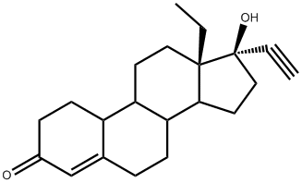
Chemical formula | C₂₁H₂₈O₂
CAS no. | 797-63-7
Specification | USP/BP
Details | 白色或类白色结晶粉末药物,溶于氯仿、丙酮，微溶于甲醇，不溶于水。熔点再201-212℃.左炔诺孕酮为炔诺孕酮的异构体，是炔诺孕酮的生物活性有效成分，具有强效孕激素活性，并有雄激素、雌激素和抗雌激素活性。左炔诺孕酮于雌激素配伍是目前国内外应用广泛的短期口服避孕药之一。
左炔诺孕酮

乙基沃氏物（左炔中间体）
Product name | Methoxydienone
Chemical name | 18-Methyl-3-methoxy-2,5(10)-estradien-17-one
Chemical structure | 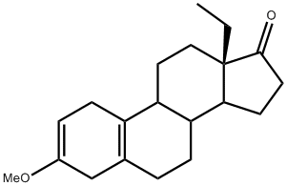
Chemical formula | C₂₀H₂₈O₂
CAS no. | 2322-77-2
Specification | 95%
Details | 白色粉末状，分子量300.44，沸点448℃at 760mmHg。沃式反应物，左炔诺孕酮中间体。

诺孕酯
Product name | Norgestimate
Chemical name | 17β-(Acetoxy)-13-ethyl-18,19-dinorpregn-4-en-20-yn-3-oxime
Chemical structure | 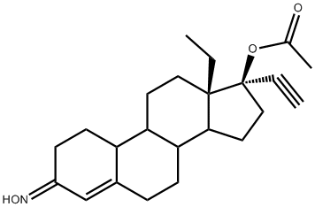
Chemical formula | C₂₃H₃₁NO₃
CAS no. | 35189-28-7
Specification | USP
Details | 别名高诺酮肟，炔诺肟酯，白色粉末状，新的强效孕激素，活性比甲基炔诺酮稍强，抑制排卵作用显著，并无雄激素和雌激素活性，但有抗雌激素作用。对脂代谢影响小，耐受性良好。

去氧孕烯
Product name | Desogestrel
Chemical name | 18-Methyl-11-methylene-19-norpregn-4-en-20-yn-17β-ol
Chemical structure | 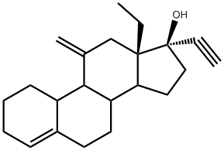
Chemical formula | C₂₂H₃₀O
CAS no. | 54024-22-5
Specification | USP
Details | 白色或类白色晶体，分子量： 310.473 ，密度： 1.07g/cm3 ，熔点： 109-110℃， 是强效排卵抑制剂,尚能改变宫颈粘液稠度、抑制子宫内膜发育。为口服强效孕激素，没有雄激素和雌激素活性。

乙基酮（去氧孕烯中间体）
Product name | Desogestrel intermediate
Chemical name | 11-Methylene- 18-methylestra-4-en-17-one
Chemical structure | 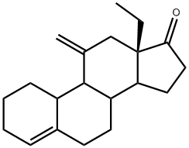
Chemical formula | C₂₀H₂₈O
CAS no. | 54024-21-4
Specification | 98%
Details | 白色结晶粉末状，医药中间体，去氧孕烯中间体。

依托孕烯
Product name | Etonogestrel
Chemical name | 17α-Ethynyl-17β-hydroxy-18-methyl-11-methylene-4-estren-3-one
Chemical structure | 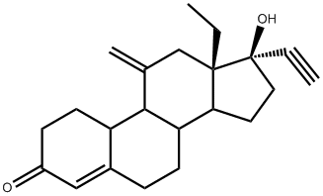
Chemical formula | C₂₂H₂₈O₂
CAS no. | 54048-10-1
Specification | USP/EP
Details | 白色或类白色晶体，分子量324.46，激素类原料药。

11α-羟基乙基双酮
Product name | 11α-hydroxy-18-methyl-4-estren-3,17-dione
Chemical name | 11α-hydroxy-18-methylestra-4-ene-3,17-dione
Chemical structure | 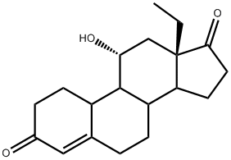
Chemical formula | C₁₉H₂₆O₃
CAS no. | 53067-82-6
Specification | 98%
Details | 医药中间体，密度1.19，分子量302.4.

乙基双酮（依托孕烯中间体）
Product name | DL-Ethylgonendione
Chemical name | 18-Methyl-4-estren-3,17-dione
Chemical structure | 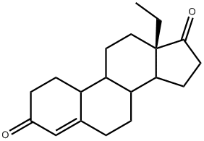
Chemical formula | C₁₉H₂₆O₂
CAS no. | 23477-67-0
Specification | 企业标准（In-house standard）
Details | 分子量286.41，纯度99%，依托孕烯中间体。

孕二烯酮
Product name | Gestodene
Chemical name | 17α-Ethinyl-17β-hydroxy-18-methylestra-4,15-dien-3-one
Chemical structure | 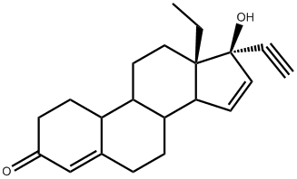
Chemical formula | C₂₁H₂₆O₂
CAS no. | 60282-87-3
Specification | USP/EP
Details | 白色或类白色结晶粉末。从丙酮-己烷结晶，熔点197.9℃。[α]D22-185.7°(C=0.5，氯仿)。 属孕激素一类，为迄今孕激素作用最强而使用剂量最低的一种避孕药。其孕激素活性为左旋甲炔诺酮的2倍，并无雄激素和雌激素活性，有抗雌激素作用，用作抗孕激素药 。

15α-羟基乙基双酮（孕二烯酮中间体）
Product name | Gestodene Intermediate
Chemical name | 15α-Hydroxy-13β-ethyl-4-gonene-3,17-dione
Chemical structure | 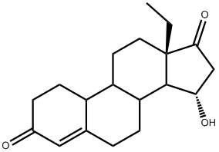
Chemical formula | C₁₉H₂₆O₃
CAS no. | 60919-46-2
Specification | 98%
Details | 淡黄色至白色粉末，分子量316.43，纯度$≥98\%，孕二烯酮中间体。$

孕三烯酮
Product name | Gestrinone
Chemical name | 13β-Ethyl-17β-hydroxy-18,19-dinorpregna-4,9,11-trien-20-yn-3-one
Chemical structure | 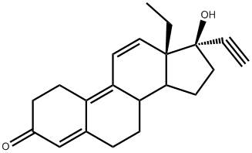
Chemical formula | C₂₁H₂₄O₂
CAS no. | 16320-04-0
Specification | USP
Details | 分子量308.42，溶于甲醇、乙醇和DMSO，微溶于水，熔点150-152$℃。$中等强度孕激素，具有较强的抗孕激素和抗雌激素活性，亦有很弱的雌激素和雄激素作用，临床用作探亲避孕药或事后避孕药。

孕三烯酮中间体
4,9 物
Product name | Estra-4,9-diene-3,17-dione
Chemical name | 19-Norandrosta-4,9-diene-3,17-dione
Chemical structure | 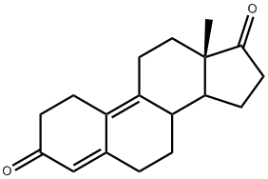
Chemical formula | C₁₈H₂₂O₂
CAS no. | 5173-46-6
Specification | 98%
Details | 白色或类白色结晶性粉末，熔点大于等于135℃，分子量270.37，激素类药，用作医药中间体。

19-去甲系列
醋酸炔诺酮
Product name | Norethisterone acetate
Chemical name | 17β-Acetoxy-19-norpregn-4-en-20-yn-3-one
Chemical structure | 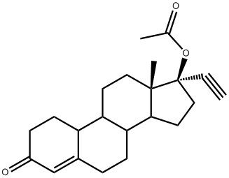
Chemical formula | C₂₂H₂₈O₃
CAS no. | 51-98-9
Specification | USP/EP
Details | 分子量340.46，晶体粉末状，孕激素类药，用于月经不调、子宫功能性出血、子宫内膜异位症等。

庚酸炔诺酮
Product name | Norethisterone enanthate
Chemical name | 17α-Ethynyl-19-nortestosterone-17-enanthate
Chemical structure | 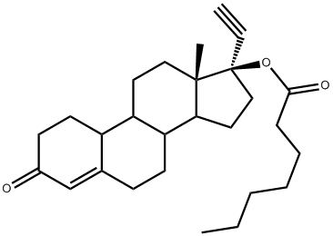
Chemical formula | C₂₇H₃₈O₃
CAS no. | 3836-23-5
Specification | 企业标准
Details | 呈白色晶体、无色针状结晶等外观形式长效孕激素，肌注后贮存在肌肉组织中逐步缓慢释放而发挥长效避孕作用。其主要作用为抑制排卵，尚能影响宫颈粘液稠度和抑制子宫内膜生长发育。

群勃龙醋酸酯
Product name | Trenbolone acetate
Chemical name | 4,9,11-Estratrien-17β-acetoxy-3-one
Chemical structure | 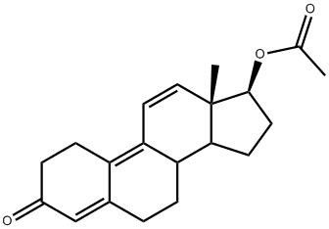
Chemical formula | C₂₀H₂₄O₃
CAS no. | 10161-34-9
Specification | 企业标准
Details | 淡黄色或黄色结晶性粉末，熔点范围: 72-78℃，纯度$≥98\%$雄激素、同化激素类药。

群勃龙庚酸酯
Product name | Trenbolone enanthate
Chemical name | 4,9,11-Estratrien-3-one-17β-enanthate
Chemical structure | 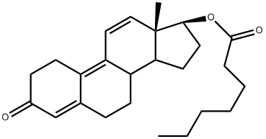
Chemical formula | C₂₅H₃₄O₃
CAS no. | 472-61-5
Specification | USP31
Details | 淡黄色或黄色结晶性粉末，分子量382.54，纯度$≥97\%，医药原料，雄性激素。$

甲基双烯醇酮
Product name | 9(10)-Dehydronandrolone
Chemical name | 17β-Hydroxy- 4,9-estradien-3-one
Chemical structure | 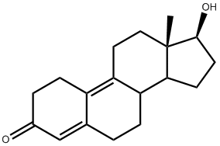
Chemical formula | C₁₈H₂₄O₂
CAS no. | 6218-29-7
Specification | 企业标准
Details | 白色结晶性粉末，分子量：272.38，含量$≥$98%，孕激素中间体。

四烯雌酮
Product name | Altrenogest
Chemical name | 17β-Hydroxy-17α-(2-propenyl)-4,9,11-estratrien-3-one
Chemical structure | 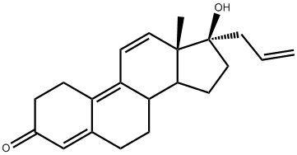
Chemical formula | C₂₁H₂₆O₂
CAS no. | 850-52-2
Specification | 企业标准
Details | 粉末状化合物，分子量310.4，熔点范围116-121℃，纯度$≥98\%，$医药中间体。

利奈孕醇
Product name | Lynestrenol
Chemical name | 19-Nor-17β-pregn-4-en-20-yn-17α-ol
Chemical structure | 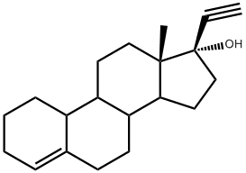
Chemical formula | C₂₀H₂₈O
CAS no. | 52-76-6
Specification | BP
Details | 白色粉末状，分子量284.4，熔点158℃，别名类兴盖斯托，炔雌烯醇，去氧炔诺酮，医药原料。

烯丙雌醇
Product name | Allylestrenol
Chemical name | 17α-Allylestr-4-en-17β-ol
Chemical structure | 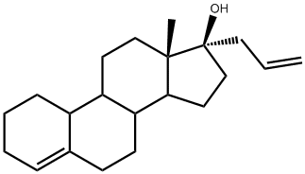
Chemical formula | C₂₁H₃₂O
CAS no. | 432-60-0
Specification | 企业标准
Details | 白色或类白色结晶性粉末，分子量300.49，纯度$≥98\%，$可增强绒毛膜活性，促进内源性孕酮及 HCG 的分泌，促使胎盘功能正常化；升高催产素酶的浓度及活性，降催产素水平；提高子宫的兴奋阈值，拮抗前列腺素对子宫的刺激作用。无雌激素、雄激素活性。适用于先兆流产、习惯性流产、先兆早产。

替勃龙
Product name | Tibolone
Chemical name | 17β-Hydroxy-7α-methyl-19-norpregn-5(10)-en-20-yn-3-one,
Chemical structure | 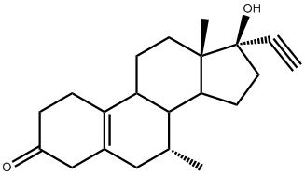
Chemical formula | C₂₁H₂₈O₂
CAS no. | 5630-53-5
Specification | 企业标准
Details | 白色或类白色结晶性粉末，分子量312.45，别名甲异炔诺龙，纯度$≥98\%，雄激素，同化激素类药，用于妇女更年期综合症。$

替勃龙中间体
Product name | Tibolone 3-Dimethyl Ketal
Chemical name | 17β-Hydroxy-7α-methyl-3,3-dimethoxy-19-norpegn-5(10)-en-20-yn
Chemical structure | 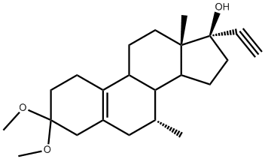
Chemical formula | C₂₃H₃₄O₃
CAS no. | 105186-33-2
Specification | 企业标准
Details | 分子量358.52，纯度$≥98\%，$替勃龙中间体。

替勃龙醚化物
Product name | Tibolone etherate
Chemical name | 7α-Methyl-3,3-dimethoxy-5(10)-estren-17-one
Chemical structure | 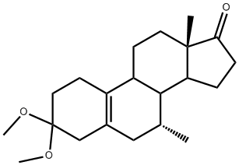
Chemical formula | C₂₁H₃₂O₃
CAS no. | 88247-84-1
Specification | 企业标准
Details | 白色结晶性粉末，分子量332.48，纯度$≥99\%，医药中间体。$

地诺孕素
Product name | Dienogestrel
Chemical name | 17α-Cyanomethyl-17β-hydroxyestra-4, 9-dien-3-one
Chemical structure | 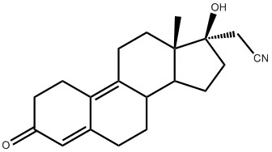
Chemical formula | C₂₀H₂₅NO₂
CAS no. | 65928-58-7
Specification | 企业标准
Details | 白色结晶性粉末，分子量311.42，纯度$≥$99%，别名地诺孕诺，双烯孕氰，为新开发的避孕新药，由于强大的抑制排卵作用而用于口服避孕，可用于治疗子宫内膜异位症。

3-缩酮
Product name | 3-Ketal-Estra-5,10-dien-3,17-dione  (Ethylene Deltenone)
Chemical name | Cyclic-3-(1,2-ethanediyl acetal)-estra-5(10),9(11)-dien-3,17-dione
Chemical structure | 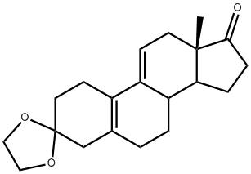
Chemical formula | C₂₀H₂₆O₃
CAS no. | 5571-36-8
Specification | 99%
Details | 本品为白色或类白色粉末，用于合成有机原料或医药中间体，科研单位研究。

乌利司他
Product name | Ulipristal acetate
Chemical name | 17α-Hydroxy-11β- [4- (dimethyl-amino) phenyl] -19-nor-pregna-4,9-diene-3,20-dione
Chemical structure | 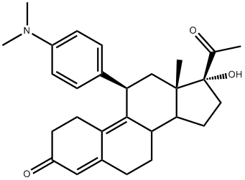
Chemical formula | C₂₈H₃₅NO₃
CAS no. | 159811-51-5
Specification | USP
Details | 白色结晶性粉末，分子量433.59，医药中间体原料,用于合成醋酸乌利司他。。

乌利司他中间体
Product name | Ulipristal acetate intermediates
Chemical name | 3,3,20,20-Bis(ethylene-dioxy)-19-norpregna-5(10),9(11)-diene-17α-ol
Chemical structure | 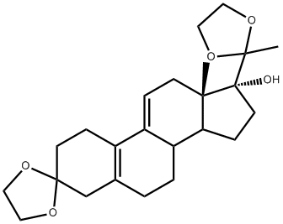
Chemical formula | C₂₄H₃₄O₅
CAS no. | 54201-84-2
Specification | 企业标准
Details | 白色粉末状，分子量402.53，乌利司他中间体。

雌激素系列
雌酚酮
Product name | Estrone
Chemical name | 1,3,5(10)-Estratrien-3-ol-17-one
Chemical structure | 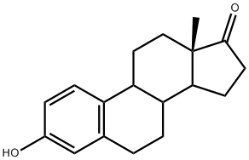
Chemical formula | C₁₈H₂₂O₂
CAS no. | 53-16-7
Specification | USP/EP/BP
Details | 白色粉末状，分子量270.37，熔点258-261$℃$，医药中间体。

雌二醇
Product name | Estradiol
Chemical name | Estra-1,3,5(10)-triene-3,17β-diol
Chemical structure | 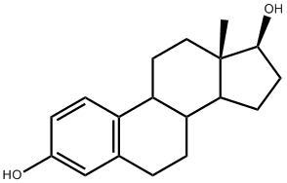
Chemical formula | C₁₈H₂₄O₂
CAS no. | 50-28-2
Specification | USP
Details | 白色或灰白色结晶粉末状，分子量272.39，熔点173℃，医药原料，补充雌激素不足。

雌三醇
Product name | Estriol
Chemical name | Estra-1,3,5(10)-triene-3,16α,17β-triol
Chemical structure | 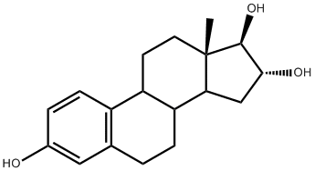
Chemical formula | C₁₈H₂₄O₃
CAS no. | 50-27-1
Specification | USP
Details | 白色结晶性粉末，分子量288.17，熔点281-282℃，医药原料，用于治疗白细胞减少症,对前列腺肥大、前列腺癌也有一定疗效。

炔雌醇
Product name | Ethinyl estradiol
Chemical name | 17α-Ethynyl-1,3,5(10)-estratrien-3,17β-diol
Chemical structure | 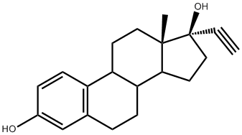
Chemical formula | C₂₀H₂₄O₂
CAS no. | 57-63-6
Specification | EP
Details | 白色至类白色结晶粉末状，分子量296.41，雌激素类原料药。

戊酸雌二醇
Product name | Estradiol Valerate
Chemical name | 1,3,5 (10) – Estratrien-3,17β- diol -17-pentanoate
Chemical structure | 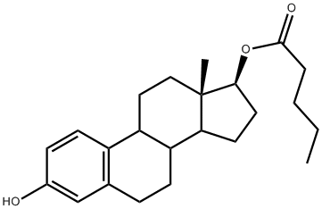
Chemical formula | C₂₃H₃₂O₃
CAS no. | 979-32-8
Specification | USP
Details | 白色结晶性粉末，分子量356.51，医药原料药，用于闭经，更年期综合症，减少乳汁分泌、前列腺癌等。

苯甲酸雌二醇
Product name | Estradiol Benzoate
Chemical name | 1,3,5(10)-Estratriene-3,17β-diol-3-benzoate
Chemical structure | 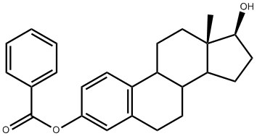
Chemical formula | C₂₅H₂₈O₃
CAS no. | 50-50-0
Specification | 企业标准
Details | 白色或微黄色结晶性粉末，分子量376.50，熔点191-196℃，医药原料，能促进女性生殖器官的生长和发育。

尼尔雌醇
Product name | Nilestriol
Chemical name | 3-Cyclopentoxy-17α-ethynyl-1,3,5 (10)-estratrien-20-yn-16α,17β-diol
Chemical structure | 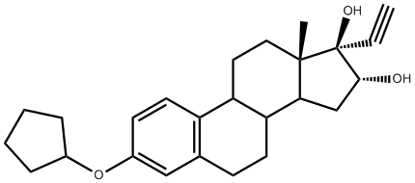
Chemical formula | C₂₅H₃₂O₃
CAS no. | 39791-20-3
Specification | EP/CP/USP
Details | 白色粉末状，分子量380.53，雌激素类药，用于治疗因雌激素缺乏而引起的更年期综合症。

孕激素系列
醋酸美仑孕酮
Product name | Melengestrol Acetate
Chemical name | 17α-Acetoxy-6-methyl-16-methylene-pregna-4,6-diene-3,20-dione
Chemical structure | 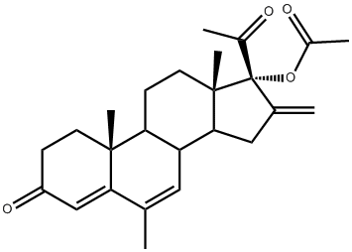
Chemical formula | C₂₅H₃₂O₄
CAS no. | 2919-66-6
Specification | 企业标准
Details | 淡黄色结晶粉末，分子量396.53，优良孕激素，作为兽用药物以埋植或液体剂型用于牛的同步发情或催长。

美仑孕酮中间体
Product name | 16-Dehydropregnenolone acetate
Chemical name | 3-Acetoxy-5,16-pregnadien-20-one
Chemical structure | 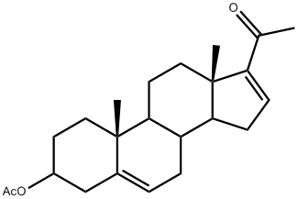
Chemical formula | C₂₃H₃₂O₃
CAS no. | 979-02-2
Specification | 企业标准
Details | 白色结晶粉末，无异嗅、无气味，在空气中稳定，易溶于乙醇、甲醇，不溶于水。熔点170-178℃， 用作甾体激素药物中间体，可制造皮质激素、蛋白固化激素类、雄性激素类、黄体激素类的药物

屈螺酮
Product name | Drospirenone
Chemical name | 6β,7β:15β,16β-Dimethylene-3-oxo-17α-pregn-4-ene-21,17-carbolactone
Chemical structure | 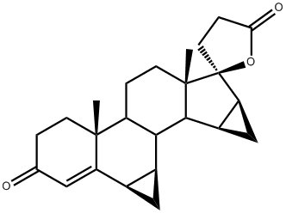
Chemical formula | C₂₄H₃₀O₃
CAS no. | 67392-87-4
Specification | CP
Details | 白色或类白色结晶粉末，分子量366.50。是目前唯一与天然孕酮特性相近的孕激素，相较于传统口服避孕药中所含的孕激素，其化学结构更接近于天然孕激素。

DHEA
Product name | DHEA, Dehydroepiandrosterone
Chemical name | 3β-Hydroxy-5-androsten-17-one
Chemical structure | 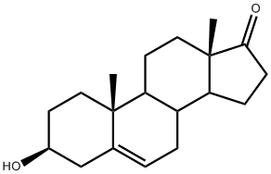
Chemical formula | C₁₉H₂₈O₂
CAS no. | 53-43-0
Specification | 企业标准
Details | 白色结晶性粉末，分子量288.43，中文名去氢表雄酮，用于生产甾体激素药物和避孕药的主要原料。

双羟DHEA
Product name | 双羟DHEA
Chemical name | 3β,7α,15α-Trihydroxy-5(6)-androsten-17-one
Chemical structure | 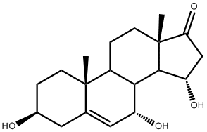
Chemical formula | C₁₉H₂₈O₄
CAS no. | 2963-69-1
Specification | 企业标准
Details | 白色或类白色晶体，分子量320.43，用于合成有机物原料和药物中间体。

米非司酮
Product name | Mifepristone
Chemical name | 11β-(4-(dimethyl amino) phenyl)-17β-Hydroxy-17α-(1-propynyl)-estra-4,9-dien-3-one
Chemical structure | 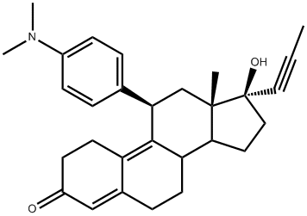
Chemical formula | C₂₉H₃₅NO₂
CAS no. | 84371-65-3
Specification | USP
Details | 淡黄色结晶性粉末；无臭；无味，分子量429.60，为强抗孕激素，能与孕酮受体和糖皮质激素受体结合，可作为非手术性抗早孕药

其他
阿比特龙
Product name | Abiraterone
Chemical name | 17-(3-Pyridinyl)-androsta-5,16-dien-3β-ol
Chemical structure | 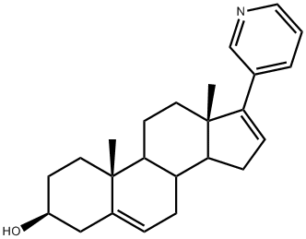
Chemical formula | C₂₄H₃₁NO
CAS no. | 154229-19-3
Specification | 企业标准
Details | 白色粉末状，分子量349.52,医药原料。

依普利酮
Product name | Eplerenone
Chemical name | 9α,11- Epoxy-17β-hydroxy-3-oxo-pregn-4-ene -7α-carboxylic acid-21,17-carbolactone
Chemical structure | 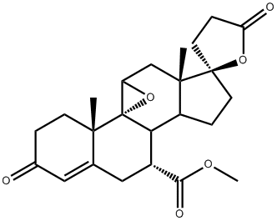
Chemical formula | C₂₄H₃₀O₆
CAS no. | 107724-20-9
Specification | BP/USP
Details | 白色或类白色晶体，分子量414.50，是一种新型的选择性醛固酮受体拮抗剂，只作用于盐皮质激素受体，而不作用于雄激素和孕酮受体。

依西美坦
Product name | Exemestane
Chemical name | 6-Methylenandrosta-1,4-diene-3,17-dione
Chemical structure | 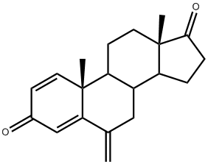
Chemical formula | C₂₀H₂₄O₂
CAS no. | 107868-30-4
Specification | 企业标准
Details | 白色结晶性粉末，分子量296.41，是一种不可逆的甾体类芳香化酶抑制剂，结构与其底物天然雄烯二酮相似。

曲洛司坦
Product name | Trilostane
Chemical name | 4α,5α-Epoxy-3,17β-dihydroxy-2(3)-androsten-2α-carbonitrile
Chemical structure | 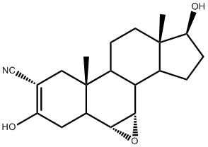
Chemical formula | C₂₀H₂₇NO₃
CAS no. | 13647-35-3
Specification | EP/CP/USP
Details | 白色粉末状，分子量329.44，可以抑制皮质激素合成过程中的3β-脱氢酶，使皮质醇、醛固酮合成减少,临床用于治疗库欣综合征(皮质醇增多症)和原发性醛固酮增多症。

地屈孕酮
Product name | Dydrogesterone
Chemical name | (18β,19α,20β)-Pregna-4,6-diene-3,20-dione
Chemical structure | 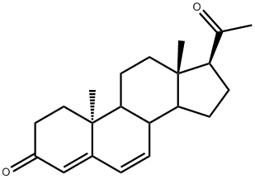
Chemical formula | C₂₁H₂₈O₂
CAS no. | 152-62-5
Specification | EP
Details

阿比特龙中间体
Product name | Dydrogesterone Intermediate
Chemical name | 17-Iodoandrosta-5(6),16-dien-3β-acetate ester
Chemical structure | 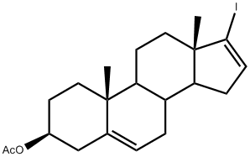
Chemical formula | C₂₁H₂₉IO₂
CAS no. | 114611-53-9
Specification | EP
Details | 白色粉末状，分子量440.37，阿比特龙醋酸酯中间体。

